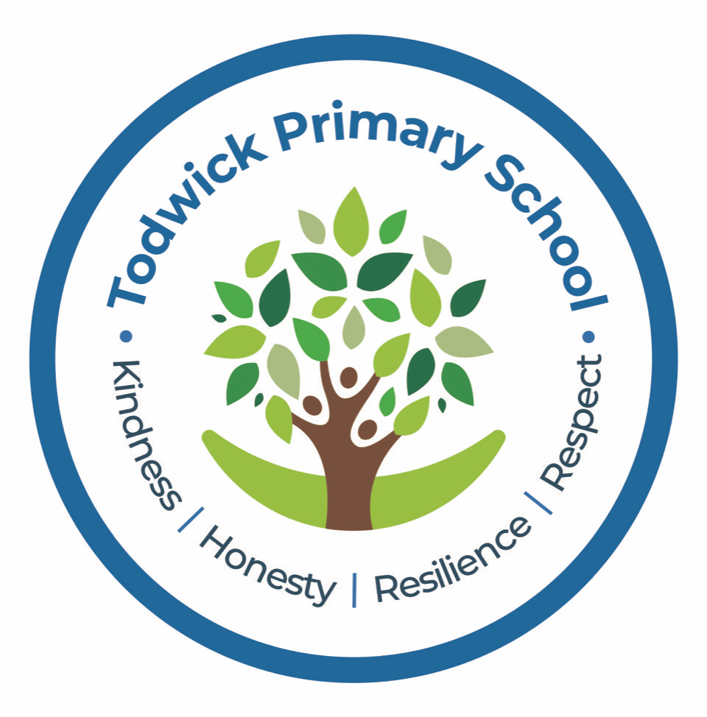

Relationships and Sex (RSE) Policy

Todwick Primary School

Updated September 2025

*(due for renewal September 2026)*

***Our Vision***

At Todwick Primary School we believe that effective RSE can make a significant contribution to the knowledge, skills and understanding needed by pupils if they are to lead confident, healthy, independent lives and to become informed, active and responsible citizens. It is an intrinsic part of the physical, intellectual and emotional growth of an individual. Relationship and sex education is delivered through the PSHE and Citizenship framework and the Science curriculum.

***At Todwick Primary School we aim to:***

* Develop confident and effective communicators who value themselves and others.
* Encourage enquiring minds.
* Meet the needs of all pupils enabling them to reach their full potential
* Provide children with an education appropriate to the world beyond the classroom
* Help children to live together within the community, displaying tolerance and sensitivity

**Aims of the RSE Policy**

* To meet the requirements of the DfES guidance on RSE.
* To help and support children through physical, emotional and moral development
* To develop in children the skills and understanding to have the confidence to approach their relationships in a positive way.
* To enable children to move with confidence from childhood through adolescence to adulthood.
* To live confident and healthy lives
* To understand the changes that occur to the human body during puberty
* To understand how a baby is conceived and born.
* To ensure children are aware of personal space and their right to privacy

**RSE in the curriculum**

In each Year Group (FS2-Y6) the children discuss key safeguarding issues linked personal space and privacy. The school uses the RSE scheme by ‘Kapow Primary’ to raise children’s awareness of these issues in an age appropriate manner. All statutory objectives are covered throughout a child’s time in primary school using a range of resources, videos and books. The teachers sensitively ensure children are aware and understand of the boundaries that should exist linked to the private areas of their body.

In Years FS2 – 4 children learn about:

* Developing the skills to have positive relationships with friends and family
* Celebrating differences and diversity
* An understanding of different family and relationship set-ups.
* Exercise and personal hygiene

In Year 5 and 6 children learn about:

* Developing the skills to be effective in relationships
* The different types of relationship, including marriage and those between friends and families. Children are made aware of different families and gender identities.
* How the body changes during puberty
* How a baby is conceived and born.
* Messages of sexuality developed in the media
* Challenging gender roles in society

At Todwick Primary School, RSE is taught through the PSHE curriculum. The programme is a graduated, age appropriate programme which will be delivered by the school staff with support and advice from health professionals. Both boys and Girls receive the same input and understand the changes that occur in their own gender as well as that of the opposite sex. The full curriculum overview is available for parents to see the lessons and objectives throughout the year in each year group.

**RSE and statutory duties in school**

RSE plays a very important part in fulfilling the statutory duties all schools have to meet. RSE helps children understand the difference between safe and abusive relationships and equips them with the skills to get help if they need it. State-funded schools have responsibilities for safeguarding and a legal duty to promote pupil well-being (Education and Inspections Act 2006 Section 38).

* Sex and Relationships Education (RSE) is an important part of PSHE Education (DfE, 2014).
* When any school provides RSE they must have regard to the [Secretary of State’s guidance](http://webarchive.nationalarchives.gov.uk/20130401151715/https:/www.education.gov.uk/publications/eOrderingDownload/DfES-0116-2000%20SRE.pdf); this is a statutory duty. Academies do not have to provide RSE but must also have regard to Secretary of State’s guidance when they do (DfE, 2013). Ofsted will evaluate how schools help to ensure a healthy lifestyle for their children (Ofsted, 2013, Subsidiary Guidance Para 64).
* It is compulsory for all maintained schools to teach the parts of sex education that fall under National Curriculum Science which must be taught to all pupils of primary and secondary age e.g. the biological aspects of puberty and reproduction (Education Act 1996, National Curriculum 2014).

Updated government safeguarding guidance is now available ([Keeping Children Safe in Education, 201](https://www.gov.uk/government/publications/keeping-children-safe-in-education--2)8) and includes a section about being alert to signs that young girls may be at risk of female genital mutilation (FGM). School summer holiday especially during the transition from primary to secondary schools is thought to be a key risk time for FGM. See also the government [Multi-agency practice guidelines: Female Genital Mutilation (2016)](https://www.gov.uk/government/publications/multi-agency-statutory-guidance-on-female-genital-mutilation) which includes a section for schools.

RSE has clear links with other school policies aimed at promoting pupils’ spiritual, moral, social and cultural development, including the:

* Anti-Bullying Policy
* Behaviour Policy
* Drug and Alcohol Education Policy
* Equal Opportunities Policy
* Health and Safety Policy
* ICT Policy and Safe Internet Use Policy
* Inclusion Policy
* RE Policy
* Safeguarding/Child Protection Policy
* Special Educational Needs Policy

**Aims and Objectives**

This policy is a working document which provides guidance and information on all aspects of RSE in the school for staff, parents/carers and governors. To be accessible to all of these groups the document needs to be available on request and presented in a way that is easy to understand.

**The role of the headteacher**It is the responsibility of the headteacher to ensure that staff and parents are informed about the RSE policy, and that the policy is implemented effectively. It is also the headteacher’s responsibility to ensure that members of staff are given sufficient training, so that they can teach effectively and handle any difficult issues with sensitivity.

The headteacher liaises with external agencies regarding the school RSE programme and ensures that all adults who work with children on these issues are aware of the school policy, and that they work within this framework. The headteacher monitors this policy on a regular basis and reports to governors, when requested, on the effectiveness of the policy.

**Equal Opportunities Statement**

The Equality Act 2010 covers the way the curriculum is delivered, as schools and other education providers must ensure that issues are taught in a way that does not subject pupils to discrimination. Schools have a duty under the Equality Act to ensure that teaching is accessible to all children and young people, including those who are lesbian, gay, bisexual and transgender (LGBT). Inclusive RSE will foster good relations between pupils, tackle all types of prejudice – including homophobia – and promote understanding and respect. The Department for Education has produced advice on The Equality Act 2010 and schools (DfE, 2014b).

Schools have a legal duty to promote equality (Equality Act, 2010) and to combat bullying (Education Act, 2006) (which includes homophobic, sexist, sexual and transphobic bullying) and Section 4.2 of the national curriculum (2014) states “Teachers should take account of their duties under equal opportunities legislation that covers race, disability, sex, religion or belief, sexual orientation, pregnancy and maternity, and gender reassignment.”

**Withdrawal from RSE lessons**

Parents/carers have the right to withdraw their children from all or part of the Relationship and Sex Education provided at school except for those parts included in statutory National Curriculum Science. Parents will be informed of when this part of the RSE curriculum is being taught in advance. Those parents/carers wishing to exercise the right to withdraw can fill in the ‘right to withdraw form’ that will be sent out prior to the lessons being taught. The head teacher, RSE co-ordinator and parents will explore any concerns and discuss any impact that withdrawal may have on the child. Once a child has been withdrawn they cannot take part in the RSE programme until the request for withdrawal has been removed. Materials are available to parents/carers who wish to supplement the school RSE programme or who wish to deliver RSE to their children at home.

**Parent consultation**

The government guidance on RSE (DfE 2000) emphasises the importance of schools working in partnership with parents and carers. Under current legislation schools should enable parents/carers to exercise their right to withdraw their children (until the age of 19) from any school RSE taught outside National Curriculum Science (Education Act 1996). This applies to maintained primary and secondary schools and includes pupils attending a sixth form that is part of a school. It does not apply to sixth form colleges and further education colleges. Parents/carers have a legal right to see the school RSE policy and to be given a copy of it (Education Act 1996). Parents/carers should also be aware that schools are legally required to provide a broad and balanced curriculum. Sex and relationships topics can arise incidentally in other subjects, such as Science, and it is not possible to withdraw pupils from these relatively limited and often unplanned discussions. Parents will be informed in advance as to when the sessions will be taught and informed of the content covered.

**Staff Professional Development**

Opportunities are provided for staff to identify individual training needs on a yearly basis and relevant support is provided.

In addition to this, support for teaching and understanding PSHE issues is incorporated in our staff training programme, drawing on staff expertise and/or a range of external agencies.

**Specific Issues within RSE**

**Language**

During all RSE lessons across KS1 and KS2, the correct terms for all body parts and functions will be used. Sex-related slang words will be clarified in a factual way and it will be made clear to pupils which words are potentially offensive and that from that point onwards, the correct terms will be used. This aims to prevent bullying of children for not knowing definitions and highlights the offensive nature of some words. Our curriculum also teaches how online sexual abuse is unacceptable alongside any form of sexual violence and sexual harassment.

**Teaching Sensitive and Controversial Issues**

Sensitive and controversial issues are certain to arise in learning from real-life experience. Teachers will be prepared to handle personal issues arising from the lessons, to deal sensitively with, and to follow up appropriately, disclosures made in a group or individual setting. Issues that we address that are likely to be sensitive and controversial because they have a political, social or personal impact or deal with values and beliefs include: family lifestyles and values, physical and medical issues, financial issues, bullying and bereavement.

Teachers will take all necessary steps to ensure that, where political or controversial issues are brought to pupils’ attention, they are offered a balanced presentation of opposing views. Teachers will adopt strategies that seek to avoid bias on their part and will teach pupils how to recognise bias and evaluate evidence. Teachers will seek to establish a classroom climate in which all pupils are free from any fear of expressing reasonable points of view that contradict those held either by their class teachers or their peers.

**Answering Difficult Questions and Sensitive Issues**

Staff members are aware that knowledge and views around RSE issues are varied. However, while personal views are respected, all RSE issues are taught without bias. Topics are presented using a variety of views and beliefs so that pupils are able to form their own, informed opinions but also respect that others have the right to a different opinion.

Both formal and informal RSE Education arising from pupils’ questions are answered according to the age and maturity of the pupil(s) concerned. Questions do not have to be answered directly and can be addressed individually later. The school believes that individual teachers must use their skill and discretion in this area and refer to the Designated Safeguarding Lead if they are concerned.

Our school believes that RSE Education should meet the needs of all pupils, answer appropriate questions and offer support. This will be regardless of their developing sexuality and be able to deal honestly and sensitively with sexual orientation, answer appropriate questions and offer support. Homophobic bullying is dealt with strongly yet sensitively. The school liaises with parents/carers on this issue to reassure them of the content and context.

**Sexual Identity and Sexual Orientation**

Todwick Primary believes that RSE should meet the needs of all pupils regardless of their developing sexuality and be able to deal honestly and sensitively with sexual orientation, answer appropriate questions and offer support. Homophobic bullying is dealt with strongly yet sensitively in line with our Anti-Bullying Policy.

**Pupils’ Access to Help and Support**

The school displays ChildLine posters, and information about any agencies that support the welfare of children is held in the main office. The School Nurse can offer confidential advice to any child.

Girls who start their periods at school are given confidential advice and support by members of staff. Girls are aware of the provision of sanitary protection which can be obtained from the school office. There is a sanitary bin in the girls’ toilets.

**Confidentiality and Child Protection/Safeguarding Issues**

As a general rule a child’s confidentiality is maintained by the teacher or member of staff concerned. If this person believes that the child is at risk or in danger, she/he talks to the named child protection co-ordinator who takes action as laid down in the Child Protection Policy. All staff members are familiar with the policy and know the identity of the member of staff with responsibility for Child Protection issues. The child concerned will be informed that confidentiality is being breached and reasons why. The child will be supported by the teacher throughout the process.

**Dissemination**

This policy is available on our school website where it can be accessed by the community. Training is regularly delivered to staff on the policy content. Copies are available from the school office on request from parents/carers.

**Monitoring and Evaluation**

The monitoring of Sex and Relationships education is carried out by the headteacher who reports to the Governors.

This policy will be reviewed on an annual basis.

**Withdrawal from RSE lessons**

Parents/carers have the right to withdraw their children from all or part of the Relationship and Sex Education provided at school except for those parts included in statutory National Curriculum Science (the lessons in which children can withdraw their children from are identified in the Y6 section of the overview below). Parents will be informed of when this part of the RSE curriculum is being taught in advance. Those parents/carers wishing to exercise the right to withdraw can fill in the ‘right to withdraw form’ that will be sent out prior to the lessons being taught. The head teacher, RSE co-ordinator and parents will explore any concerns and discuss any impact that withdrawal may have on the child. Once a child has been withdrawn they cannot take part in the RSE programme until the request for withdrawal has been removed. Materials are available to parents/carers who wish to supplement the school RSE programme or who wish to deliver RSE to their children at home.

**Working with parents and carers**

The government guidance on RSE (DfE 2000) emphasises the importance of schools working in partnership with parents and carers. Under current legislation schools should enable parents/carers to exercise their right to withdraw their children (until the age of 19) from any school RSE taught outside National Curriculum Science (Education Act 1996). This applies to maintained primary and secondary schools and includes pupils attending a sixth form that is part of a school. It does not apply to sixth form colleges and further education colleges. Parents/carers have a legal right to see the school RSE policy and to be given a copy of it (Education Act 1996). Parents/carers should also be aware that schools are legally required to provide a broad and balanced curriculum. Sex and relationships topics can arise incidentally in other subjects, such as Science, and it is not possible to withdraw pupils from these relatively limited and often unplanned discussions. Parents will be informed in advance as to when the sessions will be taught and informed of the content covered.

**Overview**

**Y2**

*Lesson breakdown*

Lesson 1: Appropriate contact: My private parts (Children will be taught the concept of privacy and the correct vocabulary for the body parts - NSPCC video**: ‘**[Pantosaurus](https://www.nspcc.org.uk/keeping-children-safe/support-for-parents/underwear-rule/?gclsrc=aw.ds&&gclid=EAIaIQobChMIvuKWtKfl6QIVQuDtCh2hkg53EAAYASAAEgJMhvD_BwE&gclsrc=aw.ds)’)

Lesson 2: Appropriate contact: My private parts are private (Children learn about safe and unsafe touches)

**Y4**

* Developing an understanding of physical and emotional changes as I grow up

*Lesson breakdown*

*Lesson 1: Introduce puberty (video explaining the changes that males and females go through as they grow from a child to an adult)*

**Y5**

* Understanding the physical changes from childhood to adulthood
* Developing an understanding of the main aspects of puberty, including menstruation
* Learning about the emotional changes during puberty

*Lesson breakdown*

*Lesson 1: Puberty (video explaining changes in the male and female body during puberty)*

*Lesson 2: Menstruation (video explaining the female menstrual cycle)*

*Lesson 3: Emotional changes during puberty*

**Y6**

* Knowing the changes experienced during puberty
* Understanding how a baby is conceived and develops

Lesson breakdown

*Lesson 1: Further developing of their understanding of physical and emotional changes of puberty*

***PARENTS HAVE A RIGHT TO WITHDRAW FROM THE LESSONS LISTED BELOW***

***Lesson 2: Conception (video explaining the biology of conception)***

***Lesson 3: Pregnancy and birth (video explaining how a baby develops in the womb and is born)***

*NB: These areas will be returned to at least once each full term depending on the needs of the class during PSHE time*